BriteLite Architecture Definition
project report
By:
João Moreira
Jochem Verburg
Muhammad Arif Wicaksana
Quan Wang
Executive Summary
This document packages the baseline, target, and gap analysis for BriteLite study case. We describe the organization, business, application, and technology structures for both baseline and target architectures. Furthermore, product architecture, business-application alignment, and application-technology relationships are explained as well. The refined goals of BriteLite is explained in the Report, and become the foundation to design the target architecture. Finally, gap analysis and impact assessment are clarified in the end of the report.
An extended executive summary will be included in the final version of this report.
Version History
Date | Version | Comments
26 May 2015 | 1 | First version: the baseline
16 June 2015 | 2 | Second version: draft of final report
23 June 2015 | 3 | Final version: additional recommendations
Table of Contents
1 Scope 3
2 Goals, Objectives, and Constraints 3
3 Architecture Principles 3
4 Baseline Architecture 4
4.1 Business Architecture Models 4
4.1.1 Organization structure 5
4.1.2 Product architecture 6
4.1.3 Process architecture 7
4.2 Data Architecture Models 9
4.3 Application Architecture Models 9
4.4 Technology Architecture Models 13
4.4.1 IT Infrastructure in BriteLite Headquarter 13
4.4.2 IT infrastructure in Veghel Site 14
4.4.3 IT Infrastructure in Dordrecht Site 14
4.4.4 IT Infrastructure in Other Locations 16
4.4.5 Infrastructure Role in Supporting BriteLite IT 16
5 Target Architecture 16
5.1 Architecture Vision 16
5.2 Business Architecture Models 19
5.3 Data Architecture Models 22
5.4 Application Architecture Models 22
5.5 Technology Architecture Models 23
6 Gap Analysis 24
7 Impact Assessment 29
7.1 Business level 29
7.2 IT Level (application and infrastructure layers) 31
7.3 Additional recommendations 32

Scope
This report discusses the IT enterprise architecture of BriteLite. The report is part of the course AIS at the University of Twente in the study year 2014-2015. This report contains an analysis of BriteLite’s company and an advice for the board of BriteLite.
BriteLite is a Dutch company specialized in producing light-bulbs, which currently faces business transformations. Having realized the current challenges and the need to anticipate the future, BriteLite decided to investigate their internal processes. They would like to get insights about their current internal processes: what is the organizational structure, which products and processes are in place, how does their IT implementation support their business processes and how effective is it, and so on. Based on this information, BriteLite would like to have a suggestion about optimizing and transforming their IT landscape to make their business processes more effective and efficient, which eventually could help them realizing their goals.
In order to achieve that, Enterprise Architecture (EA) can be utilized. The analysis of BriteLite’s EA is categorized in two models: baseline and target architecture. The baseline architecture represents the current situation of BriteLite’s business processes and functions, and also the information systems used. The target models are an advice of what the desired architecture for BriteLite could look like.
This report limits itself to describing globally a new architecture for BriteLite and defining the changes needed. BriteLite might have to investigate the advice further to implement the changes and go through the change process. Furthermore, it will not go into much detail about the architecture changes, but will focus on some major organizational changes.

Goals, Objectives, and Constraints
Currently, BriteLite has to deal with a rapid drop in the demand for their main product, incandescent light bulbs. New investors were attracted, but they want dramatic changes. Therefore the board of BriteLite wants to change its focus from the national to the international market.
BriteLite wants to get an overview of their current situation, and using this current situation would like to get an advice about needed changes. It wants to know what major changes are needed in the organization to make the company profitable again. However, this project is constrained to limited knowledge of the consultants of the products, therefore no redesign of the production process can be expected. Besides this, it gives only an initial advice about the changes that should be undergone; it won’t give a detailed description of how to get there.

Architecture Principles
In this report, the development and implementation of the BriteLite EA is realized by using the TOGAF Architecture Development Method. This method consists of several steps to come to a new architecture. However the steps taken here will be only up to the point of the Technology Architecture (step D). Besides this, step E will also have been described by developing a target architecture and describing the main changes to undergo. To model both the baseline and target architecture, ArchiMate is used. ArchiMate is an open and independent EA modelling language to support the description, analysis, and visualization of architecture within and across business domains in an unambiguous way. The consultants believe this language is relevant for this project since it concerns the whole organization, not only one part.

Baseline Architecture
The current situation of BriteLite is illustrated by the baseline architecture. It consists of business architecture models, data architecture models, application architecture models, and technology architecture models. Each model is explained in detail in the next sections.
The general overview of the architecture is depicted in Figure 1. It shows the high-level interaction between business roles, business functions, products, and applications involved in BriteLite business processes.
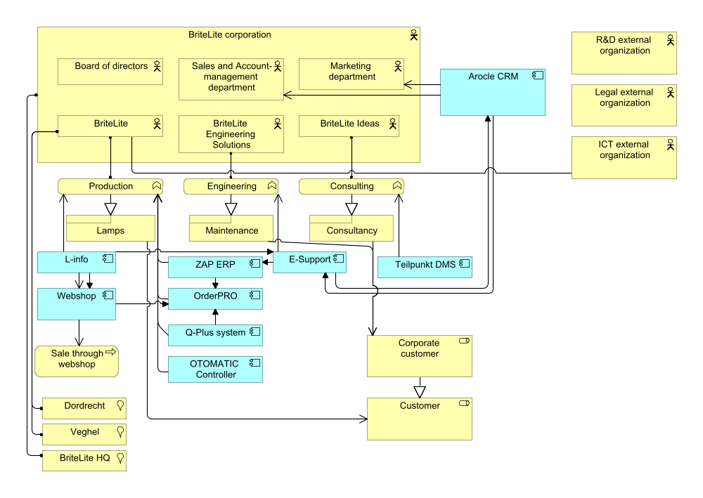
Figure 1 Total view

Business Architecture Models
The business architecture models are divided into three parts: organization structure, product architecture, and process architecture.

Organization structure
The organization structure of BriteLite is depicted in Figure 2. At the top level, there is a board of directors. There are three business lines: production (BriteLite), engineering (BriteLite Engineering Solutions), and consultancy (BriteLite Ideas). At the corporate level, there is a marketing department and a sales and account-management department.
The production business line has the largest structure. It consists of the production department, customer support team, ICT department, and finance and accounting department. The production department itself has an inventory department and a distribution department. There are two production sites, Dordrecht and Veghel. Each site has their own site manager and subdivision.

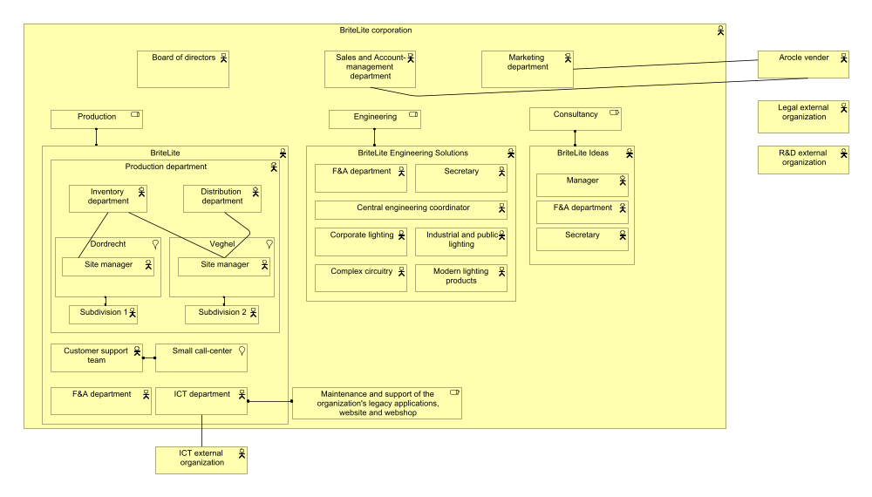
Figure 2 BriteLite organization structure
In the engineering business line, there are several units: finance and accounting department, secretary, central engineering coordinator, corporate lightning, complex circuitry, industrial and public lightning, and modern lightning products.
The consultancy business line has a smaller hierarchical structure consisting of a manager, 11 consultants, a secretary, and Finance and Accounting department.
There are relationships with external entities, especially for organizations which perform the outsourced business functionalities. Those are the external legal organization, external Research and Development organization, and ICT support. There is also the vendor Arocle, which support the CRM application used by sales and account-management and marketing departments.

Product architecture
In general, BriteLite provide their customers two things: products and services. The products are light bulbs, which can be divided into two main categories: incandescent light bulbs, and sodium-vapor lamps. The former consists of various models and series targeted for various consumer segments. The sodium-vapor lamps are intended for large customers.
The lamps are sold through two channels: normal distribution (via resellers), and directly to the customer in a web shop. Besides this, consultancy might also sell lamps.
BriteLite offers two types of services: maintenance and consultancy. The detailed illustration of the BriteLite product architecture is provided in Figure 3.
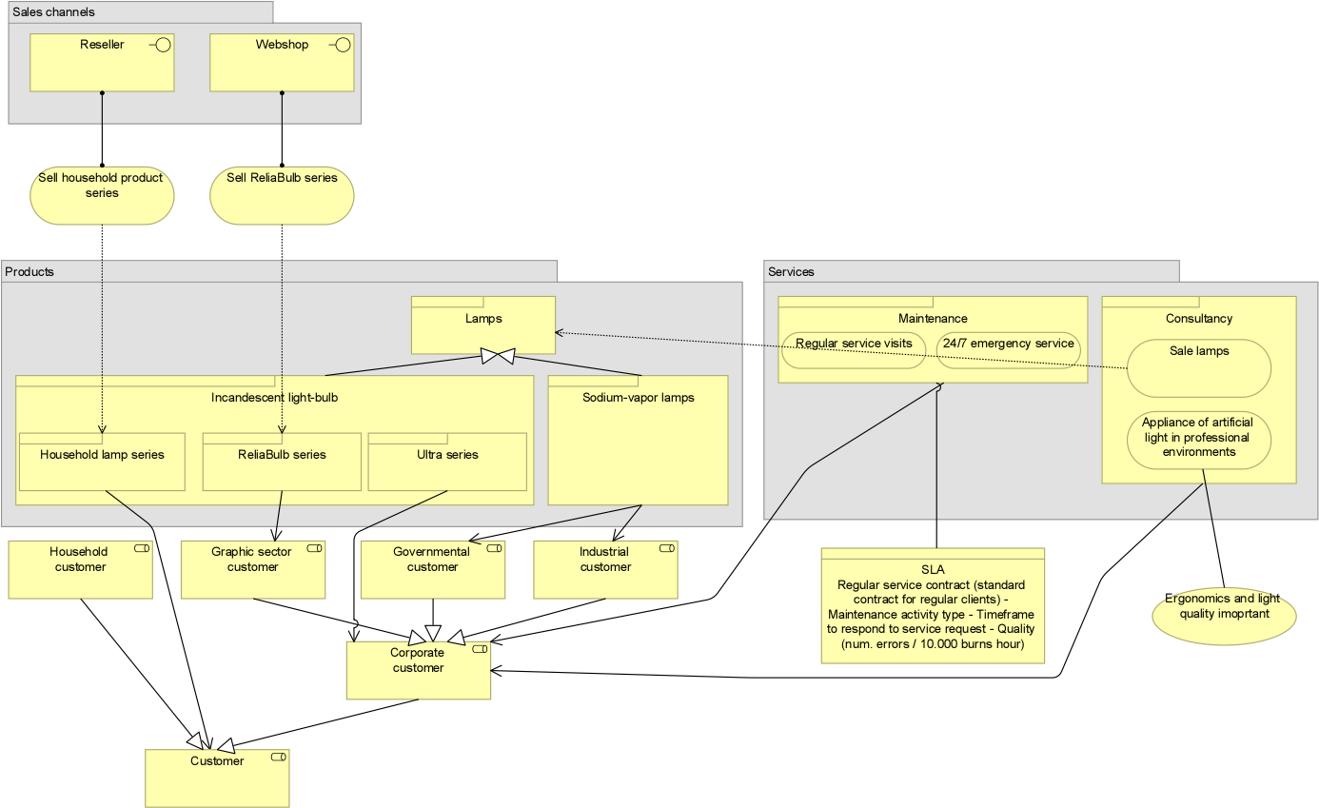
Figure 3 BriteLite product architecture

Process architecture
BriteLite’s business processes are depicted in Figure 4. The processes are linked to the appropriate entities from the organization structure (see Figure 2).
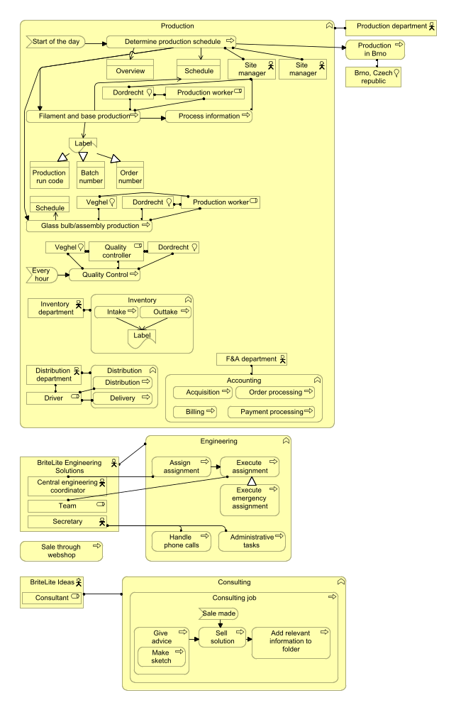
Figure 4 BriteLite business process
As can be seen, the business processes are largely dominated by the production business line, especially the processes for daily production. The business processes in the engineering and consultancy business lines are in parallel with the production business line.

Data Architecture Models
Regarding data assets and data management resources, we can consider that all data assets in BriteLite are managed by enterprise systems. We will describe data assets and their management resources based on different business lines.
First of all, we will introduce data assets and management resources in the production business line as it has most data resources. For the ERP system, which replaced the old production system in the production department, it manages 4 types of information and data assets: inventory management, production planning, production quality control and shipment tracing and tracking. For inventory management, it can be divided into outtakes and intakes, which can be furtherly divided into outtakes of raw materials, outtakes of products, intakes of raw materials and intakes of products. For production planning, it can be divided into outstanding production runs & priorities and productions schedule. The latter one is support and stored by the OTOMATIC controller and shared by ERP. Besides this, the OTOMATIC controller also stores the throughput time per batch as production logs in the machine itself. For production quality control, these data assets can be divided into status of quality control and quality control codes, which are processed and stored by QPlus system and shared by ERP system as well. For shipment tracing and tracking, these data assets can be represented by delivery status of orders, which are supported by OrderPRO system and share by ERP system as well. Besides, OrderPRO system also supports management of payment processing, order processing and billing data assets. Moreover, ERP system also manages the data asset of acquisition of raw materials.
Besides, there are some other data management resources and data assets in production business line. At the enterprise level, employees use CRM system to manage customer information and marketing campaigns while L-Info system stores specifications of all ever developed lighting products.
Secondly, engineering business line supports workload handling and keeps activities in itself as data resources by using E-support system. Besides, E-support system receives work orders from Arcole system and sends back finished case records to it. Moreover, E-support also has interfaces to ERP system and L-Info system for accessing relevant data information.
Thirdly, consultancy business line applies TeilPunkt system to manage consultant activities and data resources. TeilPunkt manages two types of data resources: Sketches information and real information for production solutions. For sketches information, it can be furtherly divided into solutions, photos& drawings of client locations and materials received from customers. These kinds of information are all kept in TeilPunkt system.

Application Architecture Models
Current existing application systems in BriteLite can be listed as follows: Arocle CRM system, E-support system, ZAP ERP system, L-Info system, OrderPRO system, QPlus system, TeilPunkt system, OTOMATIC controller and a web shop. To better illustrate how these systems support business functions, we first explain interactions and relations between these systems. And then we will link these systems with business processes in BriteLite.
First of all, there is an exchange of information between CRM system and E-support system. Working staff in engineering business line receive work orders from CRM system via E-support system. As a response, E-support will send back a record to CRM system after a case is finished.
Secondly, E-support system used by engineering business line have links with both systems in production business line. It has an interface with L-Info system so that it can access to specifications of lighting solutions directly. Moreover, it has an interface with ERP system so that engineers can access information like product inventory, product prices and so on.
Thirdly, ERP system and L-Info system in production business line are separately linked to OrderPRO system and a web shop as well. In that case, inventory management information can be exchanged between ERP system and OrderPRO system. And customers can achieve specifications of lighting products at the client side through a web page.
Fourthly, customers in the client side can use the web shop page to create orders and send them to OrderPRO system.
Fifthly, as QPlus system has the function to control quality of products. Hence, there is a connection between QPlus system and OrderPRO system. The status of quality control is sent from QPlus system to OrderPRO system and furtherly to ERP system.
Besides, TeilPunkt system has currently no connection with other systems. And the old production system is not used at all now.
After the brief explanation of interactions between systems, we will also describe how these systems support our business processes. As the production business line is the most important one in BriteLite, we will focus on business processes in this line.
First of all, team managers of the production lines determine production schedules at the start of the day via the service of production planning provided by ERP system. Then, two kinds of lighting fittings are produced in parallel: Filament and base production, Glass bulk/ assembly production, which are supported by the service of inventory management provided by ERP as well. Next, quality control is going to be carried out, which is supported by QPlus system and the status of quality control is sent to OrderPRO system and furtherly to ERP as illustrate above. Finally, distribution and delivery are supported by OrderPRO system and ERP system. Besides, for payment processing, order processing and billing, which are carried out in Accounting department, OrderPRO system provides relevant services for supporting them representatively. And for online business, the wen shop provides sell products online service for customers.
For engineering business line, E-support system supports different engineering activities, which includes assignment assign and execution, emergency assignment assign, phone calls handling and administrative tasks.
For consultancy business line, TeilPunkt provides services of drawing sketches of solutions and creating folders of production information. These two services support the whole consulting process, which contains the following sub processes: advice providing (including making sketches), solution making and creation of solution information.

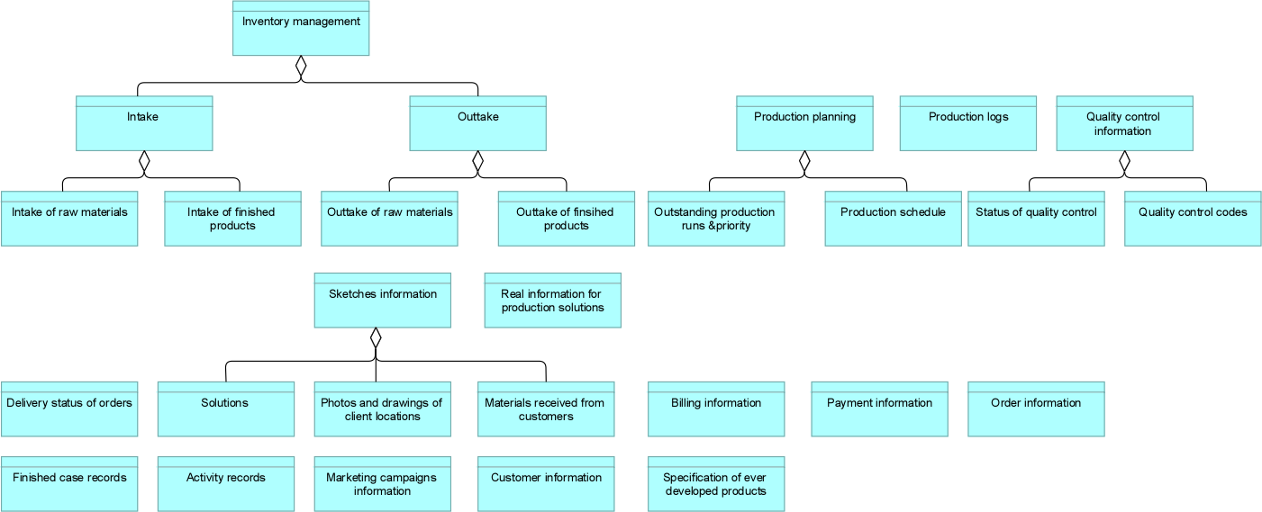
Figure 5 Information structure view
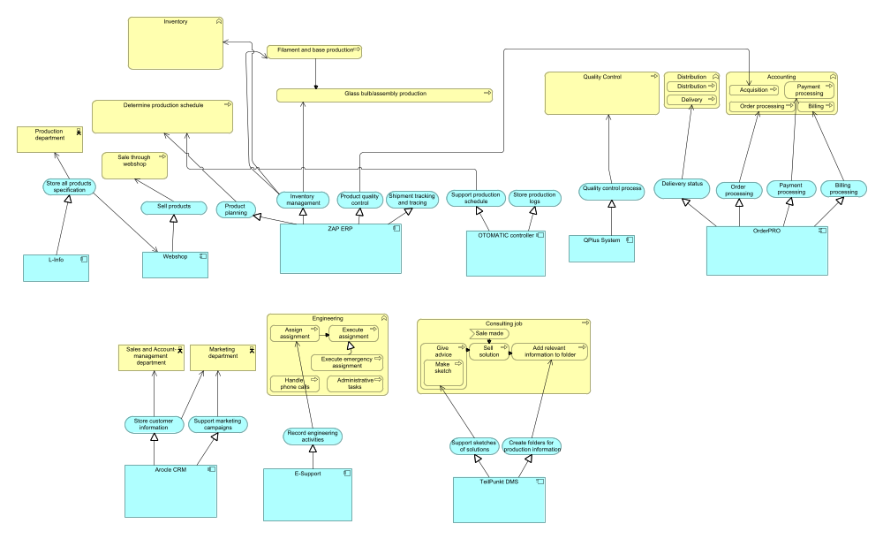
Figure 6 Application usage view
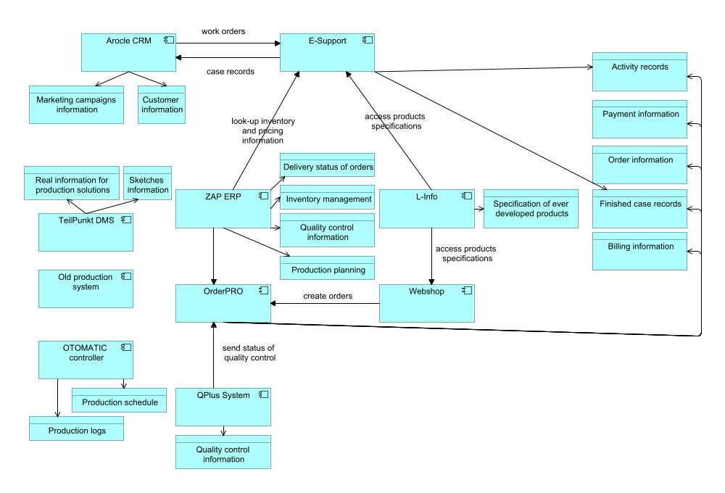
Figure 7 BriteLite application structure view

Technology Architecture Models
The current IT infrastructure used by BriteLite is spread in several locations. The configuration is shown in Figure 1

IT Infrastructure in BriteLite Headquarter
Most of the infrastructure are located in BriteLite Headquarter. There is a CRM server which is used to host Arocle CRM application, with an internal Oracle database application in the same machine. For BriteCampaign application, an HP blade server is used, with an Oracle Virtual Server is installed to run the BriteCampaign.
For BriteLite department, there are two servers available. AS400 mainframe is used to run the L-Info application, while a UNIX server cluster is used to run ZAP ERP application.
In BriteLite Ideas, a DMS server is present to run TeilPunkt application, with a simple proprietary database running on the same machine. All of the servers are connected to the Headquarter LAN, which is connected to firewall before facing the Internet. A VPN device is also available, to accommodate consultants accessing corporate network during their business travel.

IT infrastructure in Veghel Site
In Veghel site, there are two running servers. The first one, a UNIX server running OrderPRO application. Another one is a Windows 2000-based computer running QPlus System with a database application installed in the same computer. Both are connected to Veghel LAN, which connected to the Internet.

IT Infrastructure in Dordrecht Site
Similar to Veghel site, there is also a Windows 2000-based computer running a QPlus system. In addition, there is a computer running OTOMATIC controller. This computer also runs a MySQL database to support the OTOMATIC controller. Both of them are connected to the Dordrecht LAN, which is connected to the Internet.
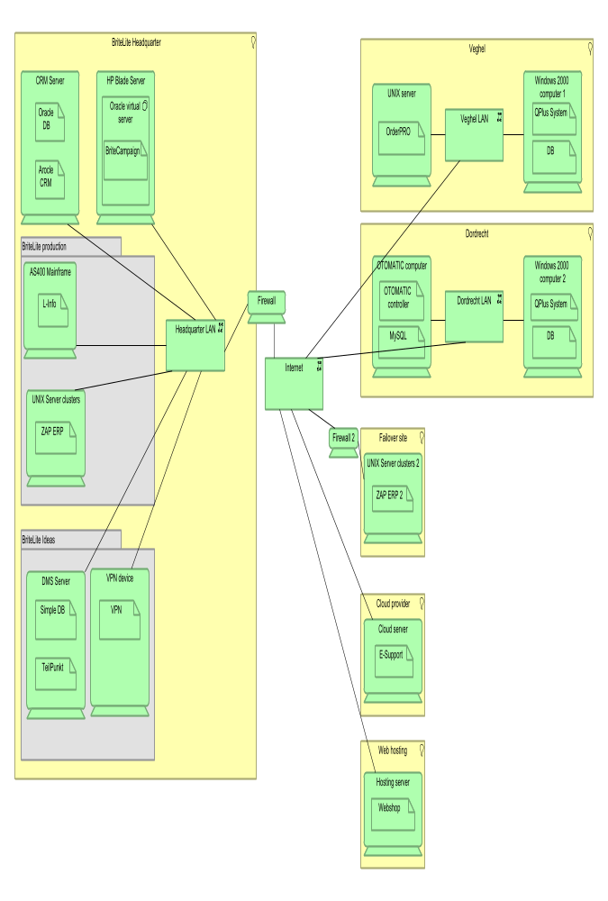
Figure 8 Infrastructure view

IT Infrastructure in Other Locations
Aside from the main locations of BriteLite mentioned before, there are also other locations used. A remote site is used to host ZAP ERP server similar to the one in BriteLite headquarter. This is intended as a failover mechanism, where the remote machine serves as a backup if the main server fails. Data between both servers are continuously synchronized, and the connection between both of them is secured by using firewall which is installed in each site.
BriteLite uses cloud technology to run the E-Support application. Hence, this application is running somewhere in the cloud infrastructure of the cloud service provider used by BriteLite. On the other hand, an external hosting company is used to host the web-based application Webshop.

Infrastructure Role in Supporting BriteLite IT
The current IT infrastructure of BriteLite supports the applications in sparse manner, in the sense that each applications has their own servers and their own database application in each machine. The technology used to run the applications also widely varies. Some of them use UNIX server, for example ZAP ERP and OrderPRO server, some of them uses Windows 2000. There is even application which uses AS400 mainframe.
The security aspect is implemented by using VPN to allow consultants accessing corporate network from the outside world, and by using firewall to filter communication traffic between the main ZAP ERP system and the backup one. However, the internal network of Veghel and Dordrecht sites are not secured with firewall yet.

Target Architecture

Architecture Vision
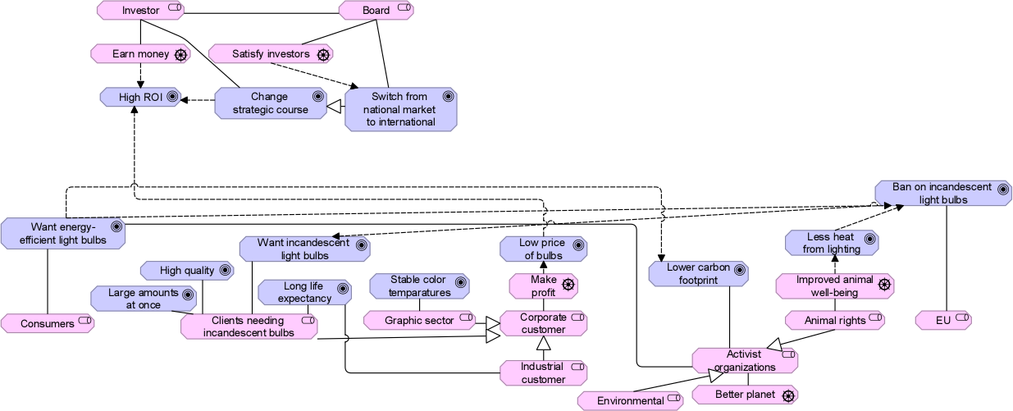
Figure 9 Motivation view
Stakeholders and goals Several stakeholders were identified, as can be seen in figure 9. These stakeholders include those being able to directly influence the organization, but also those not being able to really influence the organization at all. We chose to not model all stakeholders inside the organization, even though they might have their own valid goals, to mainly focus on the strategic reasons to change the organization. While trying to adapt the target architecture, it might be needed to do take into account some other stakeholders, but this will be straightforward: people whose jobs are influenced by the changes will be important stakeholders at that moment.
The internal stakeholders modelled are the investors, who invest money in the company and want to earn money by doing so, which is reflected by their goal of getting high return on investment. Besides this, the investors already asked the new board to change the strategic course. The other stakeholder at the company side is the board of directors, who amongst personal goals (e.g. earning a lot of money privately) have the goal to satisfy the investors. The board already announced that they want to do so by switching the orientation from the national market to the international market.
Then there’s several important external stakeholders. Consumers are more and more focusing on energy-efficient light bulbs. Besides this some goals are modelled for the other customers of BriteLite. Most important to note is that the stakeholders, customers wanting incandescent lighting, are modelled but in practice does not have to be taken into account. This is due to the European Union, which put a ban on incandescent lighting, therefore making it illegal for BriteLite to fulfil the wishes of these customers.
Other important stakeholders which might not directly influence the sales of BriteLite are activist organizations. In some cases they have very strong lobbies and besides this can influence the customers through the media. Taking into account their wishes might not only avoid negative attention, but in case of extraordinary attempts might even cause positive attention and for some customers a reason to buy BriteLite’s products. There’s two main subsets of activist organizations, environmental groups and animal rights groups. Both have in common that they want more energy-efficient light bulbs and a lower carbon footprint of organizations. The animal rights groups also want less heat from lighting because heat negatively influences animal well-being.
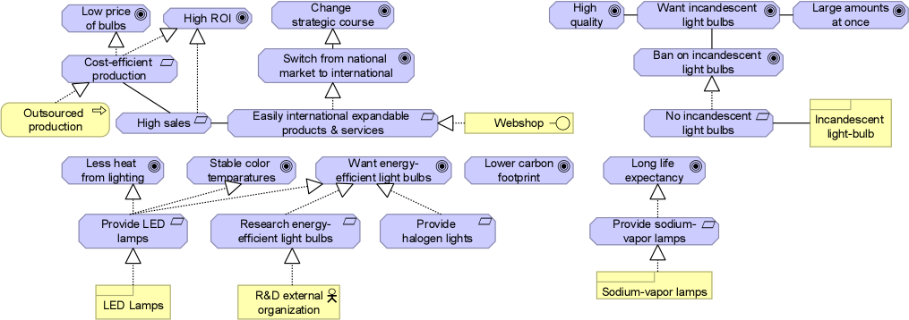
Figure 10 Requirements realization view
Derived requirements Several requirements for the target architecture could be derived from all goals, as can be seen in figure 10. First taken into account the goals of the investors. A high ROI can be achieved by both cost-efficient production and high sales, cost-efficient production can at the same time also give possibilities for lower prices, which might lead to higher sales. The board believes that these higher sales can be achieved by switching from the national to the international market. To do so, BriteLite will need products and/or services which can easily be expanded abroad.
The ban of the European Union on incandescent light bulbs, makes it clear that another requirement is that in future no incandescent light bulbs can be produced/sold. Furthermore, support for the requirement to keep providing sodium-vapor lamps is found in the goal of industrial customers to have light bulbs with a long life-expectancy.
Important goals for BriteLite are that consumers have more focus on energy-efficient light bulbs, and that the graphic sector wants stable color temperatures. The first can be achieved by both a requirement for LED lamps as well as halogen lights, but the stable color temperatures can only be realized by LED lamps. LED lamps can also realize lower heat emission. Since halogen lighting does not provide any clear advantages for BriteLite, this requirement can be ignored, since all goals can be realized by providing LED lamps. The requirement for halogen lights has been included for completeness. Because of the importance of energy-efficient light bulbs, BriteLite should also focus on continuously improving in this area. It already uses an external organization for R&D, and therefore it should be easy to change the focus of R&D to energy-efficiency.
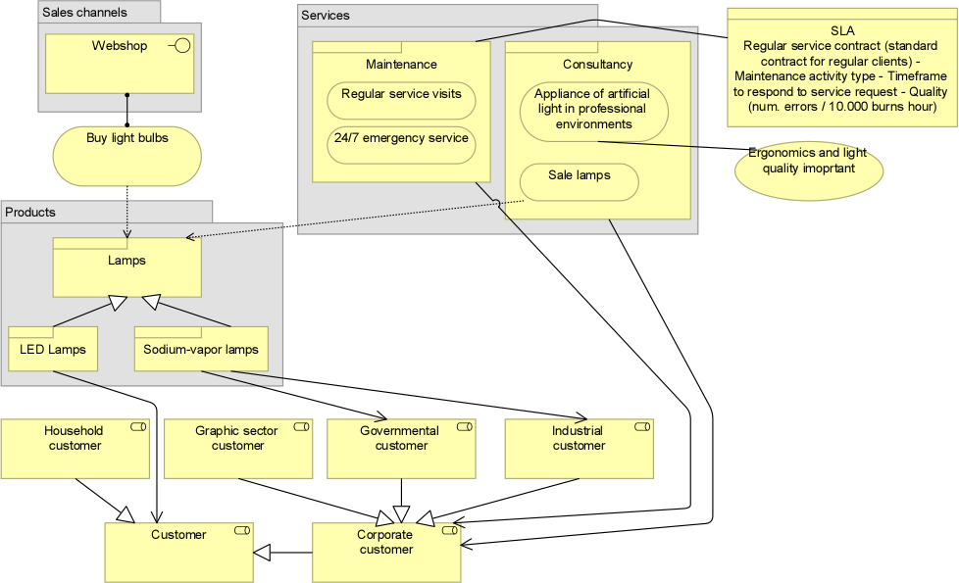
Figure 11 Target Product View
Product view BriteLite should aim to produce LED lights in the future and stop producing incandescent light bulbs. Due to the EU ban on incandescent light bulbs, no profit can be generated from producing them. LED technology is still allowed, has a rapid growth and besides this has several other advantages. Together with halogen lights it is very energy-efficient, but LED lighting also produce only a little amount of heat (which will satisfy animal rights groups). Energy-efficiency is also important since customers are giving more and more importance to it. It is good for BriteLite to focus on only one of the alternatives since new expertise has to be gained and it will mean a dramatic change in its processes. LED lighting seems to be the best choice, since the graphical sector is already an important part of BriteLite’s customers and the stable color temperature of LED lights will serve them well.
Besides this, consultancy and maintenance will still be offered in the future mainly to satisfy current customers’ needs, but it is not easy to expand these internationally due to the amount of distributed man-hours needed for it. Therefore, an important change for BriteLite will be to focus on selling through the web shop. No real changes are required in the organization to do this and it gives the possibility to easily sell on a global scale. Only minor changes would be needed to expand, e.g. translating the web shop.

Business Architecture Models
Organization structure view (see Figure 12, next page, 20) The advice is to make an F&A staff department which can be used by every business line. In this way company best practices in this area can be developed and an overall view of finance can be taken into account easily for decision within business lines. This also leads to more flexible, and therefore efficient, allocation of resources, because when one business line is busy and the other is not, this allows F&A employees to move their focus. Besides this, there will also be an ICT staff department outside the business lines, which will take care of the contact with the ICT outsourcer and is in charge of making all ICT-related decision for each business line. This re-allocation will make sure that not only wishes of the production department are taken into account, but also of other departments. The target organization structure will make sure all tasks will be executed cost-efficiently.
Besides this a drastic restructuring within the production department is needed. Veghel currently is only able to produce incandescent light bulbs and will therefore already have to be changed completely to accommodate the production of LED lighting. Dordrecht has a more modern plant though and is strategically better located for international expansion. For cost-efficiency it is therefore useful to look into the possibilities to close the Veghel-plant and move all production to Dordrecht. If Dordrecht can’t be expanded enough to fulfil the demands, outsourcing more is a real possibility as explained in the next section. An added advantage of closing the Veghel-plant is that the physical collocation of all departments gives more possibilities for sharing best practices and therefore improving all processes.
Business process view (see Figure 13, page 21) The changes proposed will also lead to a change in the production process. Only a small part of the production will take place in the original process, the sodium-vapor lamps. Group 3 consultancy does not have extensive expertise in LED lighting and therefore advices BriteLite to research the production process of this themselves. An important note is that it was not mentioned that quality of the lamps are of very high strategic importance, therefore researching the possibilities for outsourcing production of LED lighting can be very useful. In this case, LED lighting for important customers (e.g. graphical sector) can be kept in-house and the production of large batches can be outsourced. A small change in this view is that the F&A staff department is now responsible for the accounting-function within the production-function.
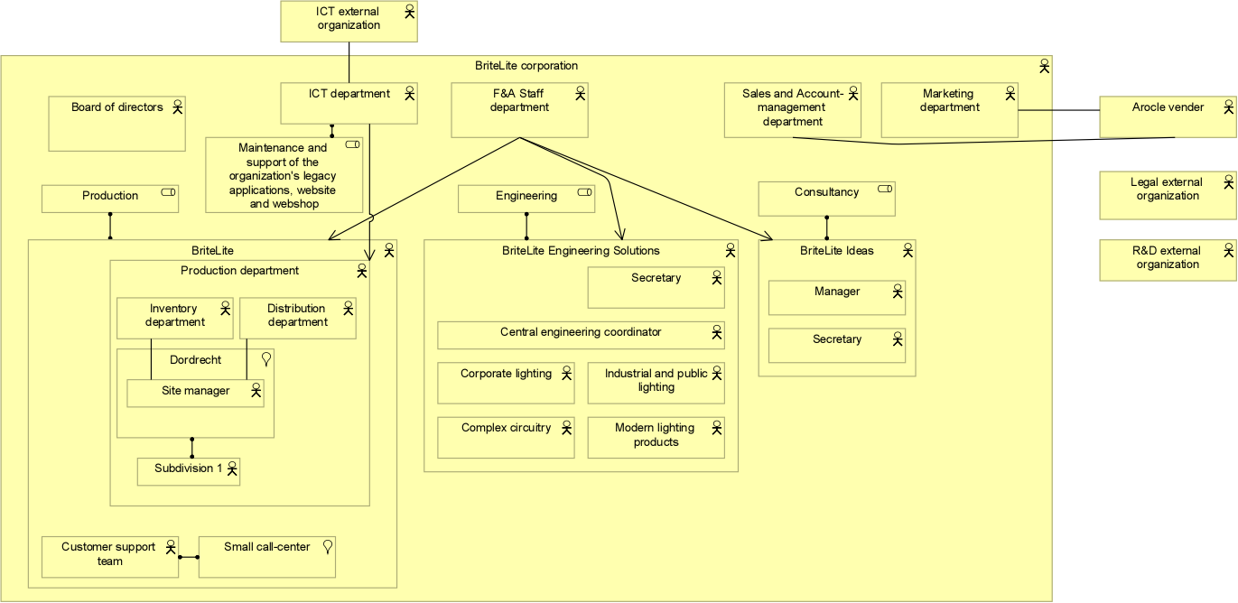
Figure 12 Target Organization Structure View
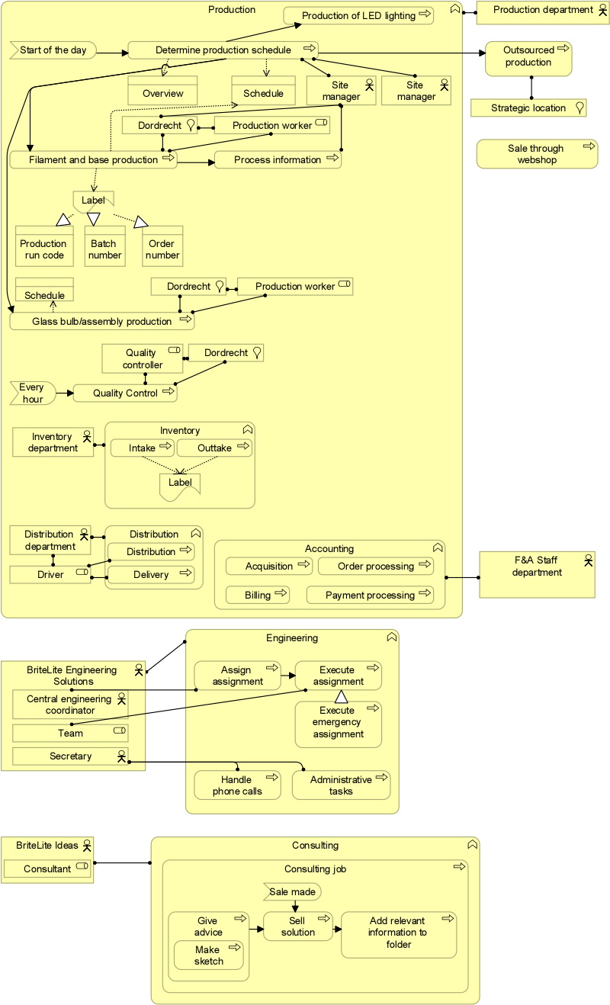
Figure 13 Target Business Process View

Data Architecture Models
In essence the information doesn’t have to change, since the business processes don’t change (the production process of LED lighting will be different, but probably the main information needed for the process will be the same). Therefore, the information model presented in figure 5 (page 11) is still relevant. However restructuring might cause the amount of information in different areas to change, e.g. more information through the web shop. Besides this, the changes proposed in the next section might cause the data to be saved at different places and integrated more efficiently. BriteLite should also look whether it wants to automate the information exchange with outsourcing parties (in case of higher production levels in outsourcing).

Application Architecture Models
Since IT is not the main business of BriteLine and outsourcing IT-related work is cheaper and a trend – through SaaS solutions and cloud computing (IaaS) – the idea is to “outsource as possible”. This will lead to the cut of the costs with license and IT-related maintenances (e.g. server’s deterioration). The following applications are assumed to have APIs where their functions are offered through SaaS solutions: ZAP ERP, Arocle CRM, E-Support, OrderPRO, OTOMATIC applications. This assumption is due to the fact that nowadays almost all enterprise applications are provided through this type of solution in the cloud, as Amazon Web Services (AWS). Following this line of though, we recommend the adoption of an Enterprise Service Bus (ESB) to enable the gradual elimination of unnecessary in-house software and hardware.
The adoption of an Enterprise Service Bus (ESB) is the main change in the application and infrastructure layers. An ESB can support the flexibility and extensibility needed by dynamic changes in business processes. The main idea of an ESB is to provide a set of “plug-and-play” enterprise functionalities, i.e. to configure the applications integration instead of coding. It is a massage backbone based on a number of standards (e.g. SOAP, REST, CORBA, RMI) to enable the implementation, deployment and management of SOA solutions. It provides docking stations for hosting applications and services that can be assembled and orchestrated, so they are made available for use by any service on the bus. The user can easily draw the service compositions through a web UI (a portal) and define how the tasks are performed.
Therefore, the aforementioned applications () are eliminated. The applications’ services are realized by the ESB, which connects to the external services offered as SaaS solutions. A migration plan of the data underlying those applications must be performed whether historical data is important to the business needs.
Regarding L-Info system, which is a “taylor-made” application and contains historical data of lights ever produced, we propose its migration for a SaaS solution, where its integration with E-Support and the WebShop can be realized by the ESB.
The Document Management System (DMS) TeilPunk was planned to have the documents’ governance migrated to corporate IT (section 3.3). It refers to the organization of the documents: the standardization of how the content is stored and making it available through an easily finding capability. Therefore, in the target architecture, we recommend the adoption of guidelines for documents governance and the migration to a SaaS DMS (e.g. MS Sharepoint).
Q-Plus system is also eliminated once it presented restrictions to support a lean process for error documentation categorized by error types and a limited ability for integration to other applications. Since it replicates the data in its own DB and is a system to control quality assurance batches only sending information to OrderPRO when a batch is closed, we recommend the implementation of this process through a service composition in the ESB. The barcode scanner can automatically open the batch.
The new architecture for the applications can be seen in figure 14. However the design of the ESB will have to be done in a separate project, so it is not clear which web services will take care of which functions. The target application structure view was excluded since in essence it only contains one application, the ESB which is also presented in figure 14.
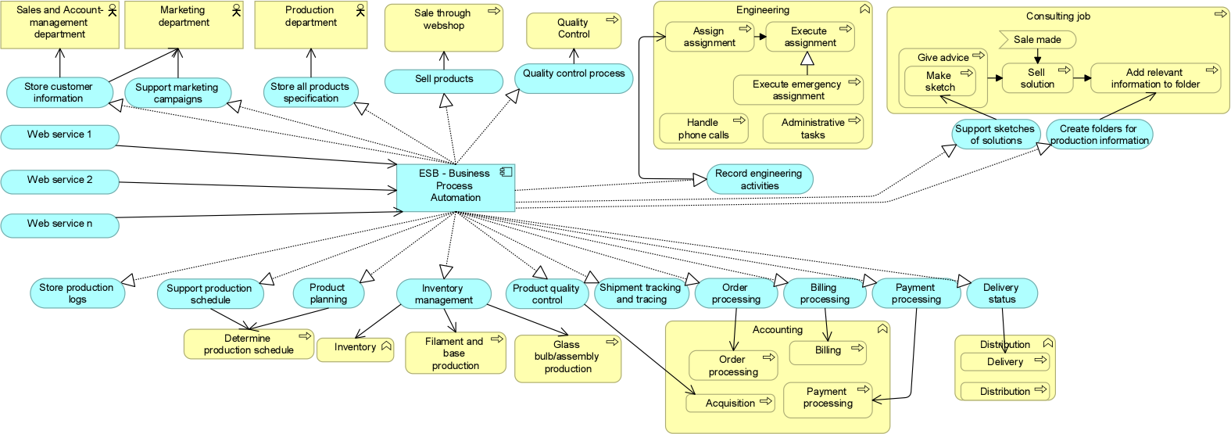
Figure 14 Target Application Usage View

Technology Architecture Models
The infrastructure BriteLite needs will be brought back much more to the basics, so BriteLite will be able to reduce the amount of maintenance costs. Besides this, the ICT department will have less responsibilities and can focus on the improvement of business processes by using IT. The Enterprise Service Bus will have to run on a server in the main site, Dordrecht, where a good network and firewall (which was not there at first) is needed. This network will be connected to the internet, so communication with web services can be established. Most infrastructure will be outsourced to services, like data storage, applications, etc. The only thing needed for BriteLite will be a server for the ESB, a good network and the user devices (e.g. laptops/PCs). Figures 15 and 16 show how the target architecture could look like, taking a generic view for the web services.
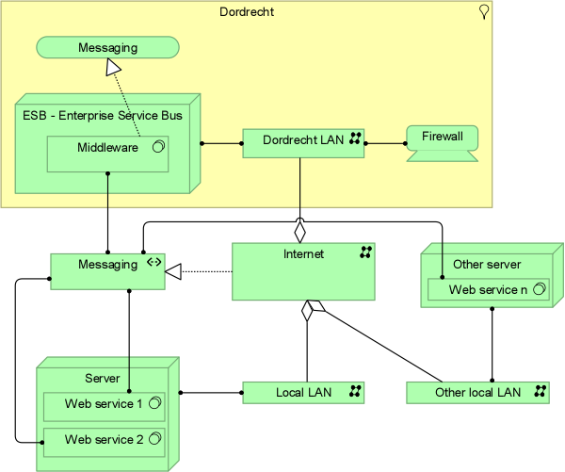
Figure 15 Target Infrastructure View

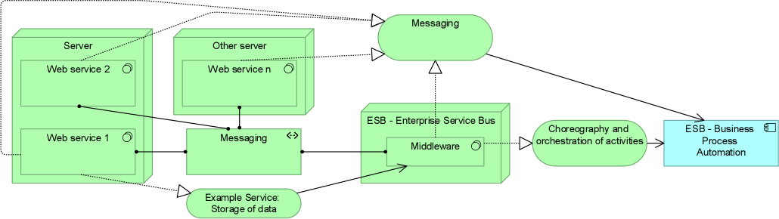
Figure 16 Target Infrastructure Usage View

Gap Analysis
A high-level analysis of the gaps between the baseline and target architecture was made by using two plateaus and the Architect tool capability of “differences between plateaus”. For each domain (business, application, data and technology) an implementation and migration view was created demonstrating the main changes made. In red are the eliminated elements, in blue the remaining elements and in green the new elements. They are illustrated by the following figures:
Total view:
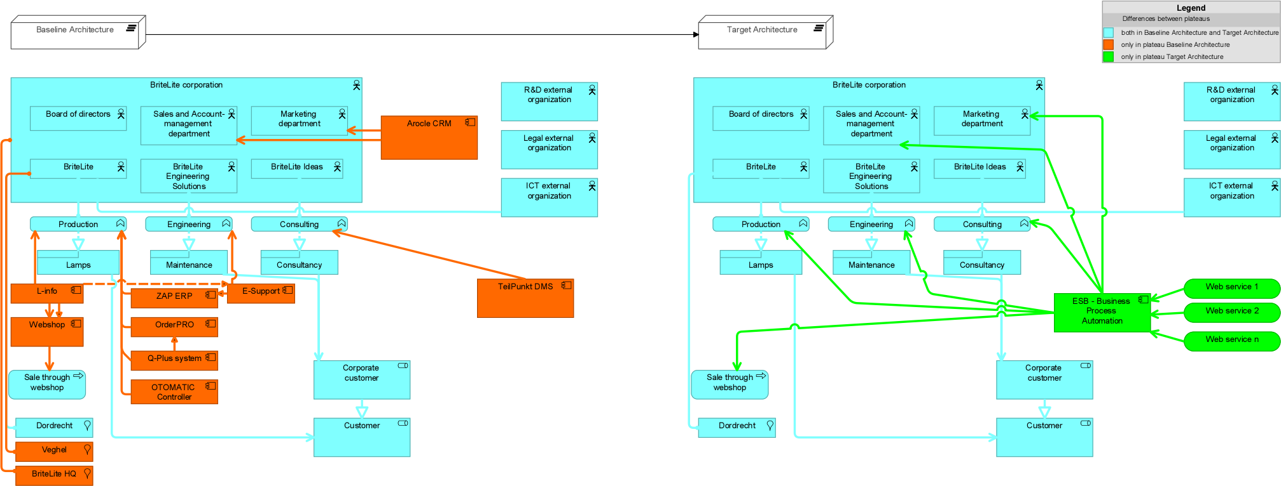
Figure 17 Gap analysis of Total View

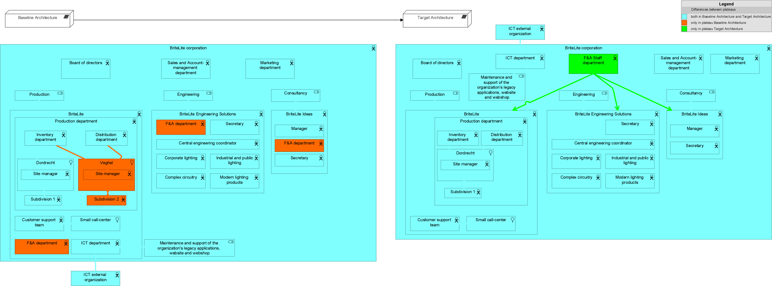
Figure 18 Gap analysis of Organization View

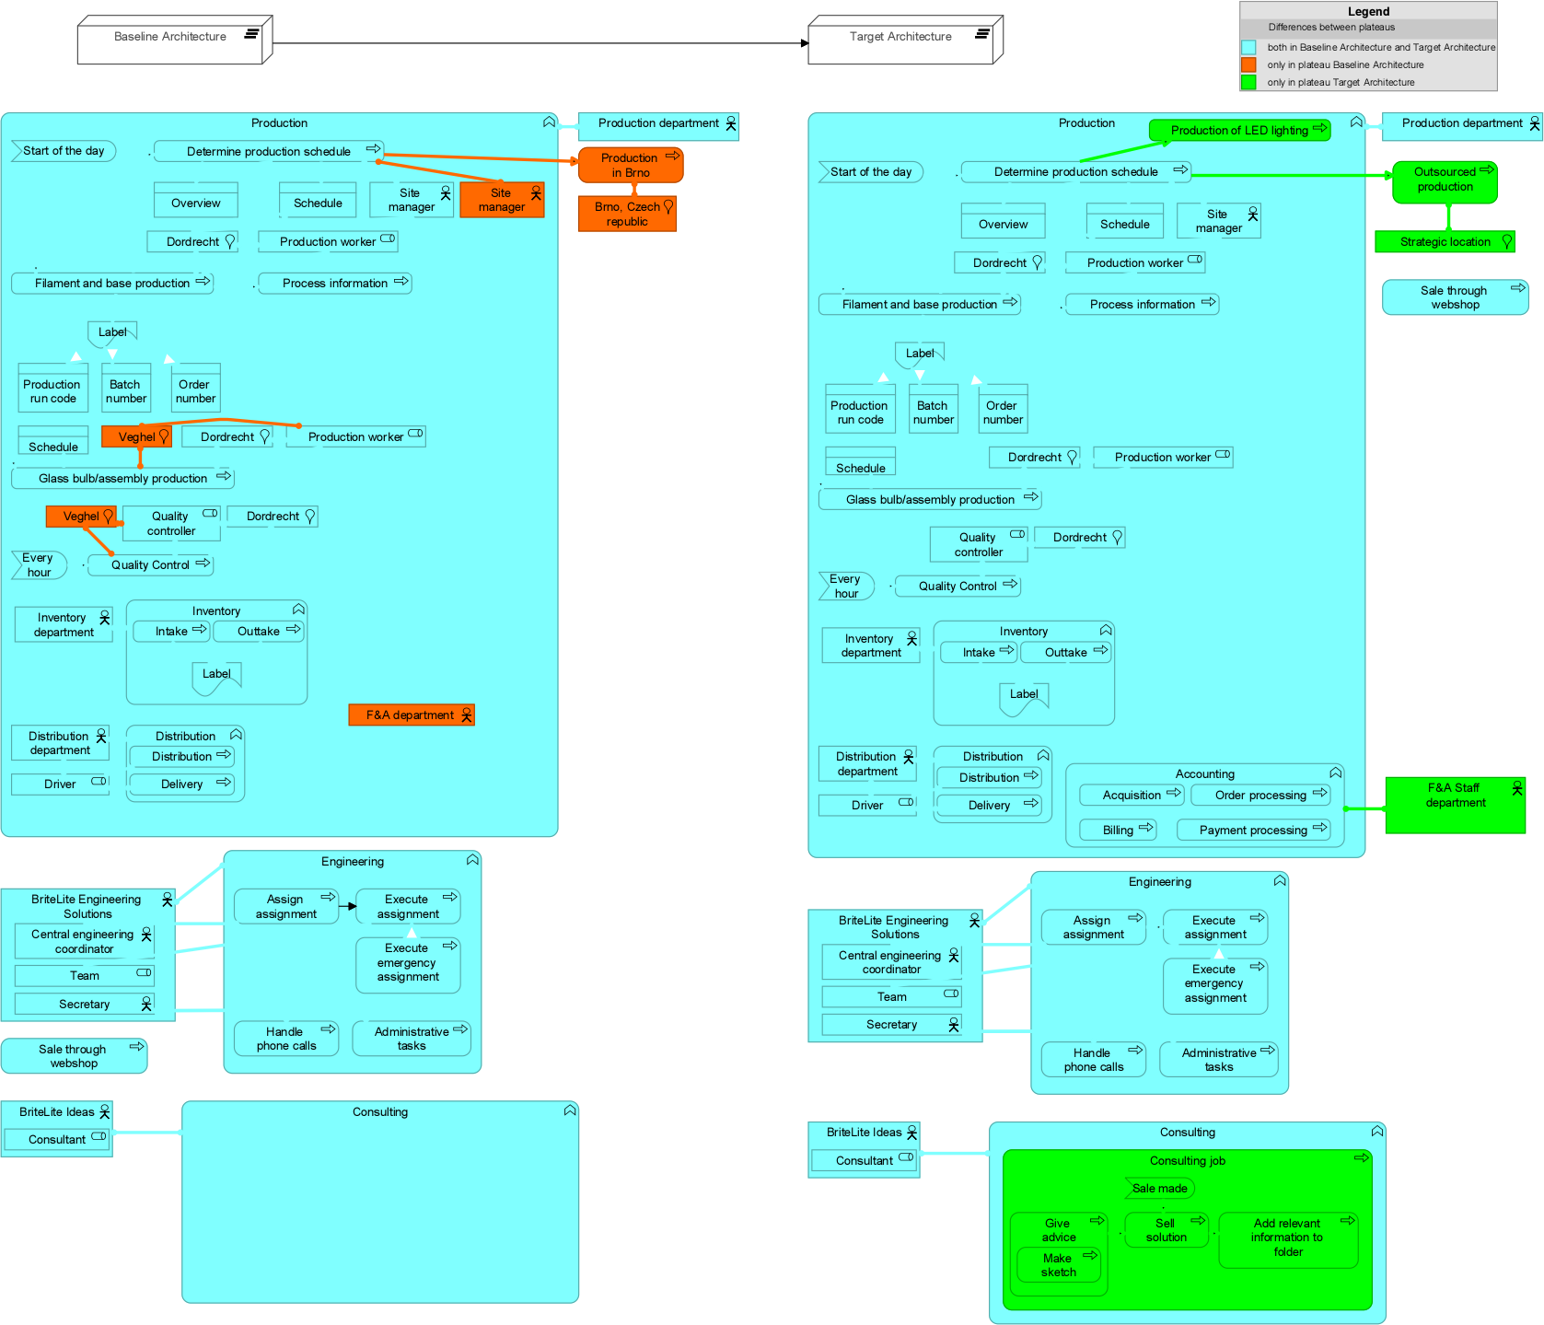
Figure 19 Gap analysis of Business Process View

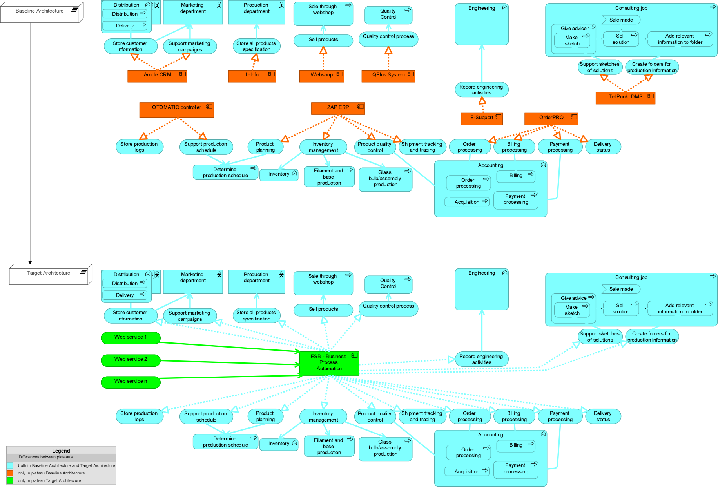
Figure 20 Gap analysis of Application Usage View

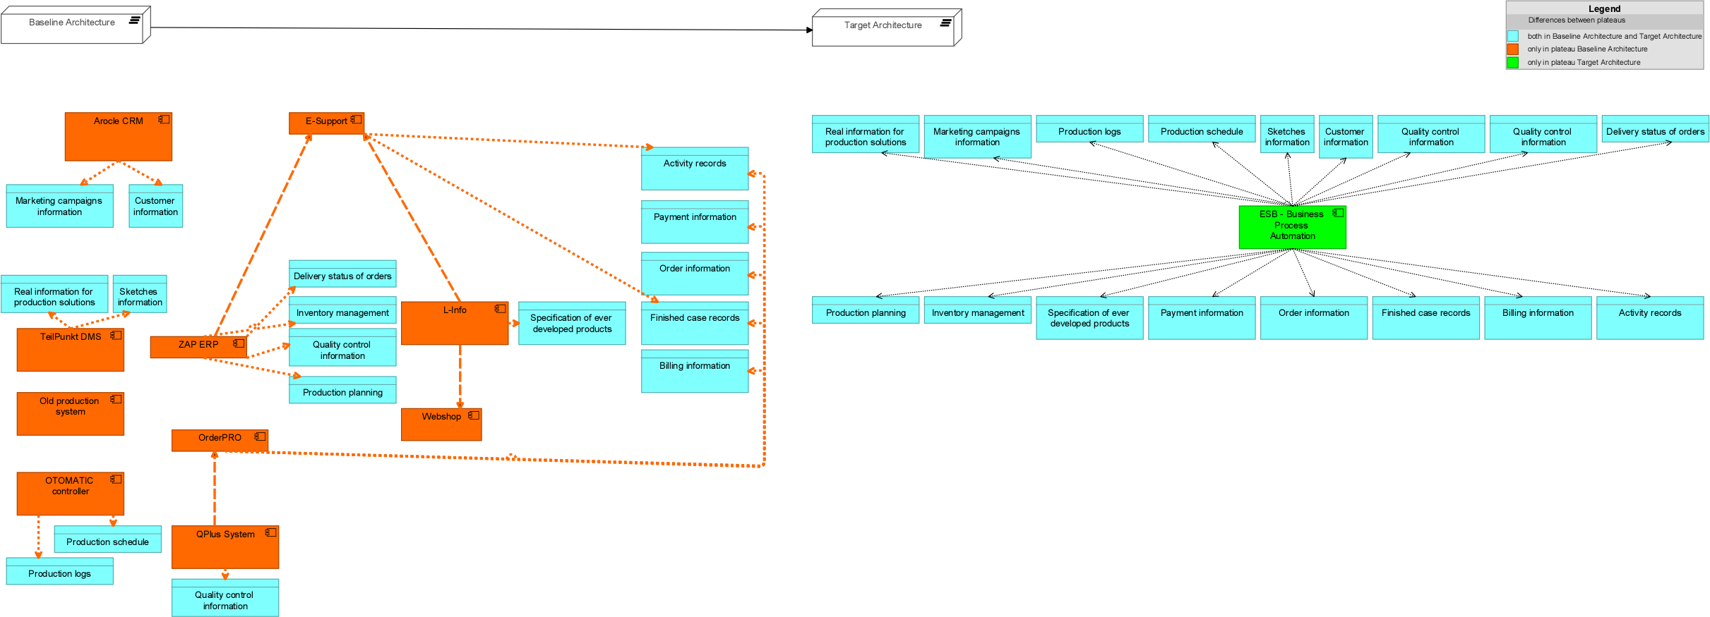
Figure 21 Gap analysis of Application Structure View

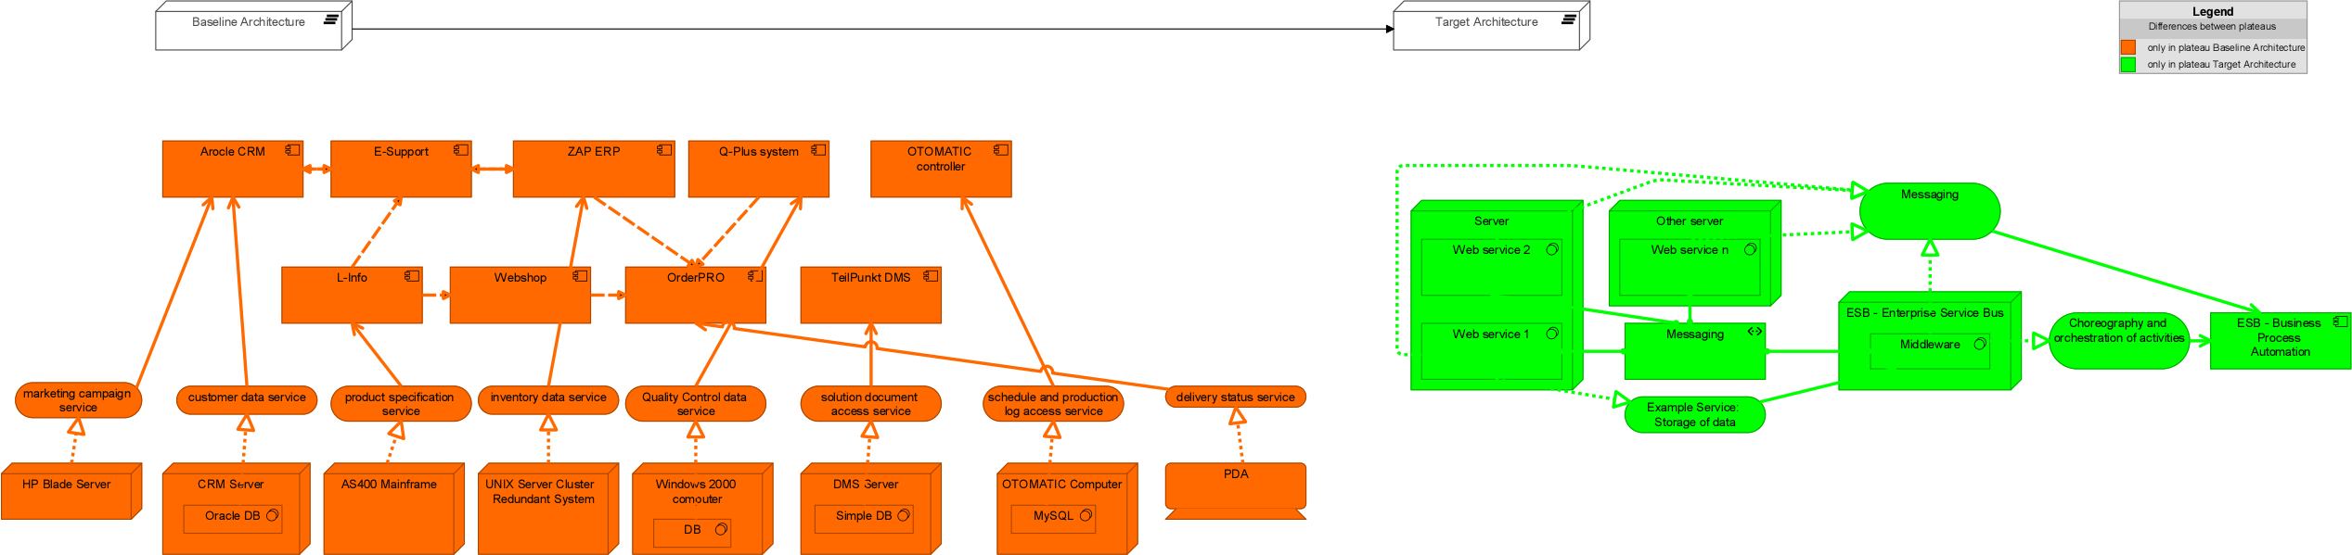
Figure 22 Gap analysis of Infrastructure Usage View

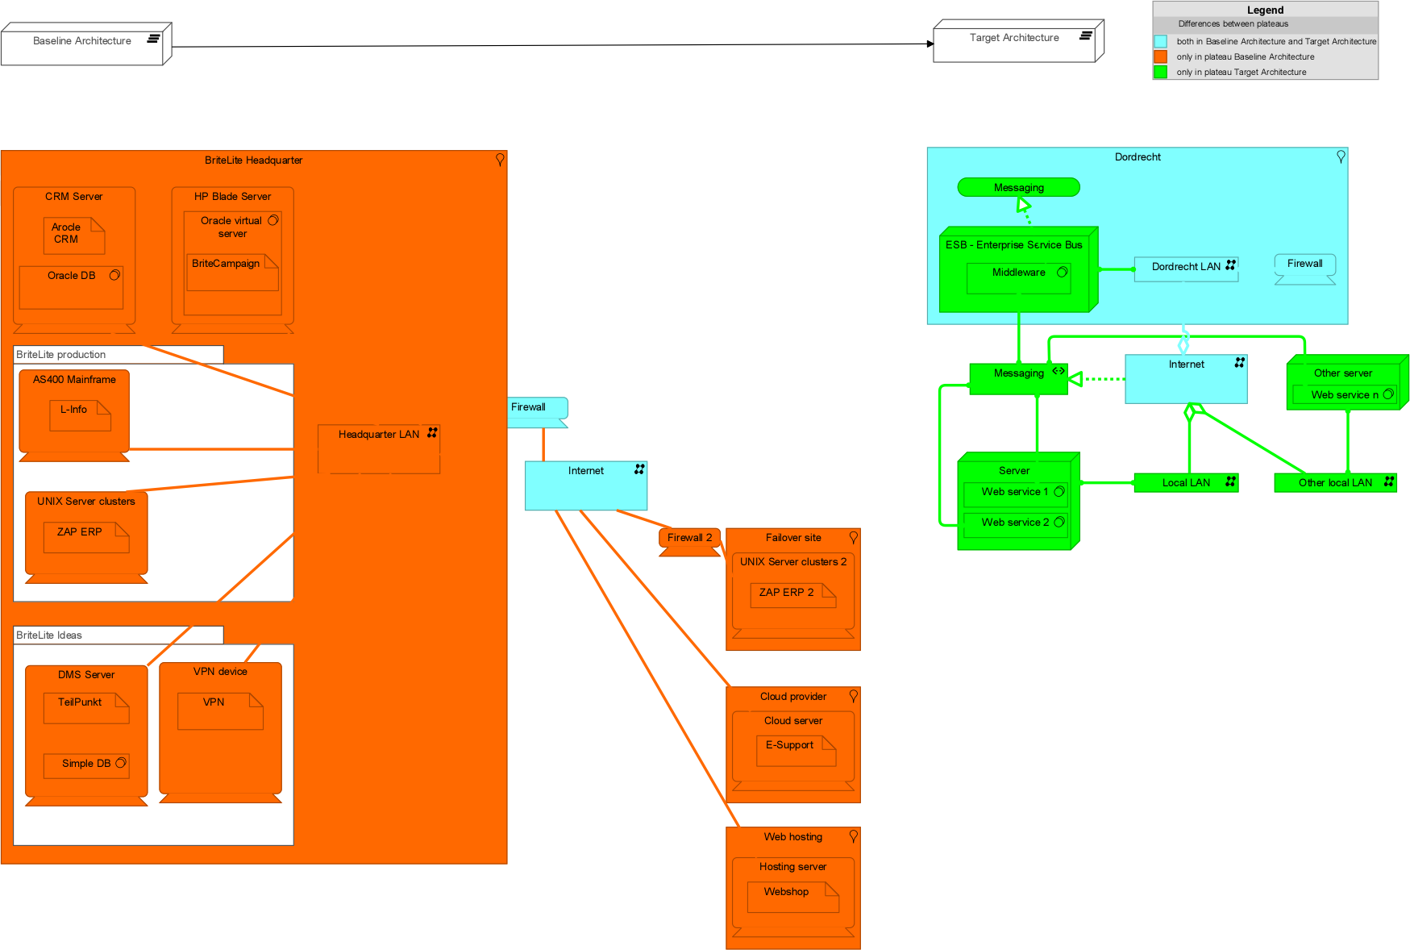
Figure 23 Gap analysis of Infrastructure View

Impact Assessment

Business level
The analysis of stakeholders and goals led to some large changes in the target architecture compared to the baseline architecture.
- Replace incandescent light bulbs by LED lights
This change drastically impacts the business of BriteLite. First, it will have to gain new expertise in the area of LED lighting, and can’t use its expertise in incandescent lighting anymore. Besides this, the production process will have to be changed.
Strategically, it could lead to a loss of current customers but winning new customers. Customers in need of incandescent lighting, won’t be satisfied by BriteLite anymore. Nevertheless, many more stakeholders are satisfied by the proposed change to use LED lighting: this also gives huge marketing opportunities focusing on the eco-friendliness of these changes.
Since it is illegal to sell incandescent light bulbs it is important for BriteLite to change to LED lights as quick as possible. However, it is important to look at all the regulations. BriteLite has opportunities to immediately take a step ahead of the competitors, since research showed of 35 researched lights, none were compliant with regulations (http://www.nu.nl/wonen-en-interieur/4070962/ledlampen-voldoen-niet-europese-eisen.html). BriteLite can therefore immediately become the first to provide good LED lights.
- More focus on energy-efficient light bulbs
The impact of this change for BriteLite itself is minimal. It will have to switch the focus of current R&D to energy efficiency. This can be achieved by re-negotiating contracts with the external organization responsible for R&D. However, BriteLite could also take a more drastic approach and in-source R&D to get more competitive advantage. Then, new people should be hired and a new department will have to be started. To keep the costs as minimal as possible, these people could mainly be responsible for cooperating with universities and R&D organizations.
- Moving from resellers to web shop only
This change mainly makes business easier for BriteLite. Having one main sales channel, makes the overview easier. No contracts with separate resellers are needed. It can impact the distribution of BriteLite though, since distribution will be done globally and to more locations. BriteLite will need to consider to what extent it wants to keep distribution in-house. Probably contracts with distribution organizations in several countries will be needed and BriteLite needs to consider how to supply to these organization most efficiently. Advantage is that it only needs a maximum of one contract per country instead of many for resellers.
Advantage of having the web shop as main sales channel is that sales predictions can be made easier. Over time a lot of information will be available and this can be used to make reliable estimates of sales.
Furthermore, at the start BriteLite can use English as the main language. The web shop should be translated into English. However, if in future certain markets seem promising and support for more languages is needed, this could be added easily. More impact is that all employees responsible for (direct) contact with (international) customers need to speak, read and write English fluently. Training will be needed, especially for the customer support team. However these costs will probably not be really high, since Dutch people in general already master the English language. Besides this, the internationalization goals of BriteLite already inevitably would lead to this investment.
This change could be realized in several months to a year, it might be good to first get the production of LED lights going so there’s enough stock to sell. Then, BriteLite might start actively promoting their products internationally.
- From decentralized F&A departments to a centralized F&A staff department
Being placed together the company wide best practices can be developed. Furthermore F&A can be more flexible, and therefore efficient, in the allocation of resources; if one business line needs much work and the other not, than employees can pick up more work in the busy business line. However, the employees in these departments will not have as much direct contact with employees of the business lines anymore. Therefore the F&A department might miss information, they usually had. To solve this processes should be defined to ensure that the F&A department always gets the right information at the right time. As soon as there is space in HQ, this change can be done. However, it might be good to have some flexiwork places at every business line.
- ICT department from Production to BriteLite
The current position of the ICT department makes sure that the department is in close contact with the Production Business Line, but might neglect the other business lines. However, the responsibilities of the department shows that it is responsible for all ICT. Their new function as staff department therefore should have the positive impact that the department takes into account the needs and wishes of all business lines, but could have the negative impact that the production department is less close to ICT.
The ICT department can immediately be made aware of their task to take into account the needs and wishes of all business lines. As soon as there is space in HQ for IT, the change can be done. However, IT might sometimes want to be closer to every business line. It can therefore share flexiwork places with the F&A department.
- Closing Veghel plant (and outsourcing more)
Closing the Veghel plant has a major impact on the organization. Therefore it will be something taking a lot of preparation. People will have to be moved, or potentially fired. The positive impact is that the location of BriteLite will be better, and besides that operations can be more efficient since they will take place in a newer plant. A possible negative effect would be that there’s no space in Dordrecht to expand and that BriteLite will have lower production capacity. Since quality doesn’t seem to be of high strategic importance, this might be solved by outsourcing on a more structured basis. If some orders do need higher quality, these products can be made in Dordrecht and all other orders can be outsourced. This will have a high impact on the organization as well since new business processed need to be in place, so the outsourcing becomes structured. The prices should be negotiated so they become less variable (as currently is the case) and agreements regarding delivery and timeliness should be made. Some people might have to be responsible for contact with the production facilities where the production is outsourced. Furthermore, BriteLite should decide how it wants to execute quality control, two main options being: having someone on location or distributing all goods through Dordrecht.
These changes can probably be done after 1.5 years when the distribution depot is also completely moved to Dordrecht. This way, all produced products can immediately go through Dordrecht.

IT Level (application and infrastructure layers)
The adoption of an ESB and the outsourcing of the majority of the IT components caused a big change in the target architecture.
- Outsource IT-related work
Outsourcing, in general, brings the need of enhancing the governance of the IT services. A set of practices enables this enhancement, e.g. ITIL (Information Technology Infrastructure Library) and ALM (Application Lifecycle Management) procedures. They support the standardization of hosting, development and maintenances, as well as code quality measures and monitoring procedures.
Outsourcing the infrastructure assets can lower the costs related to deterioration (e.g. of servers and network links), software licensing and staff’s specific knowledge (e.g. DBA, programmer, tester). Cloud-computing (also called IaaS) can realize the infrastructure outsourcing through cloud-based services (e.g. Amazon Web Services). The major issue in this choice must include the internet connection link because if it fails the entire company stops. Hybrid approaches can be considered, such as mirroring (by real-time synchronization) the main infrastructure components, such as the UNIX server clusters for ZAP system. However, this option can bring additional costs and must be avoided whether is not necessary. Other issues to be considered are: security (authentication and authorization) to connect the ESB to the external services, performance and scalability when running the processes with multiple and simultaneous actors. The cloud technologies can even increase the performance and scalability through the elasticity capability.
- Adoption of an ESB
The adoption of an ESB led to a set of basic requirements. At first, a specialist in this technology (an Enterprise Architect) is needed to manage the ESB and to plan its configuration in adequate infrastructure (e.g. a service cluster with high bandwidth link to internet). In addition, practices for business processes management (creation, modification and test) must be standardized through a process definition where the respective roles are assigned to the involved people. For example, modifying an existing process can affect the current processes’ instances and testing strategies must consider the possible impacts.
- Replace applications by service compositions in the ESB
Rewriting or evolving the existing applications is a common issue due to business changes. As section 1.4 of the book describes, in long term, rewriting is not a good strategy, but it is required (sometimes) to support the business needs. When technology is too old and is hard to make changes (takes long time and/or is expensive) it is better to rewrite, as well as when business functionalities changes so much that it is easiest to write it from sketch. Definitely, rewriting all the applications in this case is not recommended due to the high cost and possible problems with this “big bang” change – the migration process turns extremely complex and error prone.
We suggest the integration of the applications to support the business processes through an integration pattern following the SOA paradigm. This can be realized through a process integration layer that can be accessed by an unique interface (at the access layer) and calls the services layer, which exposes the applications services. Figure 16-2 of the book describes this architecture.
To expose the main services of the applications by using SaaS and IaaS a migration plan is necessary. At first, each application service (e.g. store all products specification and engineering activities – refer to section 5.4) must be provided by a (composition of) web services from the external vendors. Whether an application service is not available through SaaS, a plan to expose the service by the in-house application provider must be made. In the end, the goal is to have all application services available to be used through the ESB. Thereafter, it is recommended a smoothly and carful process for turning-off the application and turning-on its equivalent service through the ESB. A list of the applications to be removed and the impact to the business processes must be made (refer to section 6) and the migration of each prioritized. For instance, to turn off the OTOMATIC system, the store production logs and support production schedule services must be made available through the ESB, where the process of product schedule determination start using them instead of the application. As mentioned before, a precise an strong testing strategy must be draw and executed a priori. The infrastructure assets are turned-off gradually once they are not used anymore. Chapter 15 of the book provides general guidelines for changing and integrating applications based on business priorities.

Additional recommendations
Some general recommendations were added to the Britelight case, they are described below:
- Migration plan
In a real case scenario it is necessary to have a project (or a group of projects) for the migration from the baseline to the target architecture. Since we are proposing a radical change in the Britelite scenario (change the entire application and IT infrastructure), this need must be mentioned. A common approach is to design intermediary architectures (plateaus) that fits into the migration plan, divided in a set of waves, as illustrated in Figure 24. Furthermore, for each wave different plateaus can be designed as options to be followed, constrained by budget and time. Therefore, when a wave finishes the stakeholders can analyse the possibilities and chose the best options for the next wave, mitigating risks and making the necessary adjustments.
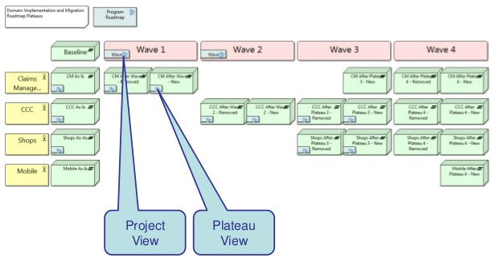
Figure 24 Target Infrastructure Usage View

- “Sensing enterprise”
This term means the use of sensing possibilities made available through interconnected sensors from an enterprise to enrich its business processes. With the advent of the Internet-Of-Things (IOT) and the cheapness of sensors, various sensors are providing data (freely or not) about the environment through the internet (linked datasets). Britelite company could make use of this technology in a set of manners. At first, by using sensors to automatically detect failures on the lamps inside the client’s environments. For instance, a sensor can be added to the lamp and transmit a message to Briteline whether the lamp stops to work, changing from reactive (waiting clients contact) to proactive. This type of solution can even be used by the marketing department, like the slogan: “If a problem occurs in the lamp, we know before you.”. This impacts the SLA’s of maintenance service, making them easier to achieve. Sensors can also be used in the production processes to control the quality of the lamps, for instance. Since it is a relatively new technology we decided not to add it to the target architecture, but with the adoption of SOA paradigm, the IT architecture would be ready to sensors adoption.
- Marketing orientations
Two trends in marketing must be mentioned as additional recommendations:
First, the technique of sentiment analysis is being used to evaluate customers opinions about products and the company brand. This is made through Social BI tools that gathers information from different sources, such as social media (Twitter, Facebook, Linkedin, etc), and tries to discover the polarization of clients’ comments through natural language processing mechanisms. Therefore, marketing campaigns can make use of this feedback, being more assertive.
Second, the adoption of techniques to understand client profiles is a trend in marketing through recommendation systems. Those are equivalent to recommendation advertisements from Google and Amazon, which are guided to the client’s preferences. In Britelite case, lamps bought by clients can give an idea of their preferences and target marketing can be made to them, recommending similar or complementar products not only from Briteline’s portfolio but also from partners (e.g. fixtures for lamps).

